THE EFFECTS OF ZINC AMINO ACID IN WALKING CATFISH (Clariasmacrocephalus) MALE BROODSTOCK MATURATION AND SPERM QUALITY

Siti-Ariza Aripin^{1*}, Orapint Jintasataporn² and Ruangvit Yoonpundh²

¹School of Fisheries and Aquaculture Sciences, Universiti Malaysia Terengganu, 21030, Terengganu, Malaysia
²Faculty of Fisheries, Kasetsart University, 10900, Bangkok, Thailand

Abstract
This study examines the effects of zinc amino acid (ZnAA) treatment to maturation and sperm quality of male Walking catfish, Clariasmacrocephalusbroodstock. The fishes were fed at a level equivalent to 3% of their body weight and this amount of diet was divided into two equal feedings per day. The gradual ZnAA levels of Control, ZnAA1 and ZnAA2 in the diet mixed in isonitrogenous and isocaloric of 37% crude protein and 9.3% crude lipid. ZnAA accumulation, broodstock maturation analysis and sperm kinetic analysis were assessed after eight weeks of treatment.The treatment has significant different in bone for ZnAA accumulation. The ZnAA treatment increased the gonadosomatic index, live sperm rate, sperm motility, sperm progressive, and lowering sperm abnormality.

Keywords: Zinc amino acid;histology; gonad; male; Catfish

Introduction

Clariasmacrocephalus is under the Clariidae family and it is an important species in aquaculture industry especially in Southeast Asia (Areerat, 1987). Captive stock usually has delay maturation due slow adult growth and sacrificing male catfish to obtain milt for artificial propagation resulting to the depletion of captive stock. Zinc is essential trace element that is required for growth and development in plants, animals, and humans (Baker and Ammerman 1995). Functions that require zinc regulation including reproduction (Maret and Sandstead 2006).Metallothionein is a zinc protein that involved in the transport, metabolism and homeostasis in tissues and cells (Kurita et al. 2013). According to Salgueiroet al. (2000), zinc plays an essential role in reproduction by zinc fingers mediation of androgens and estrogenswhich necessary for the synthesis and secretion of gonadotrophins, gonadal differentiation, testicular growth, and fertilization.Zinc also involves in prevention of oxidative stress and capturing superoxide and hydroxyl radicals by metallothionein (Menezoet al. 2011).The dietary nutrient enrichment such as zinc may trigger the production of several reproductive hormones, thus it helps the enhancement of maturation and sperm quality of C. macrocephalus. The objective of present study is to investigate the effect ZnAA diet to the maturation and sperm quality in male broodstock of the C. macrocephalus.

Materials and Methods

Theexperiment trial was carried out at the Laboratory of Nutrition andAquafeed, Department of Aquaculture, Faculty of Fisheries, KasetsartUniversity, Bangkok, Thailand. A total of 45 males were fed at a level equivalent to 3% of their bodyweight. Thefishes were randomly distributed in three treatments with three replicates. The durationof experiment was for eight weeks.Thediet consisted of 37% crude protein and 9.3% crude lipid. The diet was contained with ZnAA (Zinpro Corporation, Eden Prairie, MN USA) concentrations at 0 (control), 100ppm (ZnAA1) and 200ppm (ZnAA2) g/kg in the diet (modified Clearwater et al. 2002).Next, the broodstock was weighted before the final sampling to determine the growth performance. For histology analysis, it was done in accordance to Drury and Wallington (1967).Gonadosomatic Index was determined according to King, (1995). Eosin-nigrosin stained semen smears were done for live sperm rate, sperm concentration and sperm abnormality. Sperm kinetic characteristicwere done by Computer-Assisted Sperm Analysis (Katebiet al. 2005, Klimowiczet al. 2008). Finally, statistical analysis was analysed by one-way ANOVA (analysis of variance) and followed by the Duncan test. The means comparisons significance was tested at P<0.05.

Results and Discussion

ZnAA concentrations in bone samples were significantly different between the treatments (p = 0.001) (Figure 1A, Table 1). According to Sa et al. (2004), the role of zinc in the biology of bones is significance for bone growth. Zinc deficiencies will results to retardation because zinc stimulates bone formation (Sa et al. 2004).

Table 1:ZnAA concentration in serum, meat, liver, bone, sperm and testis with different levels of ZnAA (mean ± SD)
Treatment | Control | ZnAA1 | ZnAA2 | P value
Serum (ppm) | 5.67 ± 1.5 | 6.05 ± 1.8 | 5.34 ± 1.0 | 0.7
Meat (ppm) | 5.05 ± 0.7 | 6.07 ± 1.0 | 4.79 ± 0.4 | 0.7
Liver (ppm) | 19.06 ± 1.8 | 19.62 ± 2.6 | 17.89 ± 0.9 | 0.3
Bone (ppm) | 29.10 ^{b} ± 10.5 | 50.88 ª ± 6.7 | 50.01 ª ± 7.1 | 0.001
Sperm (ppm) | 10.48 ± 3.5 | 8.17 ± 1.1 | 14.09 ± 7.5 | 0.1
^{a,b} Values with different superscripts in a row differ significantly (P < 0.05).

ZnAAtrial have no significant difference for the weight gain between treatments. On the contrary, ZnAA treatment increased the gonadosomatic index (p = 0.002) (Fig 1B, Table 2). Histological changes in testes during the ZnAA treatment were observed in C. macrocephalus (Figure 2). In the present study, spermatozoa were found mainly in ZnAA1 and ZnAA2 treatment where the value was 38.8% (control), 60.7% (ZnAA1) and 70.7% (ZnAA2) (Table 2). Zinc regulates the synthesis and secretion of luteinizing hormone (GTH-II) and follicle stimulating hormone (GTH-I), gonadal differentiation, testicular growth, formation and maturation of spermatozoa, testicular steroidogenesis and fertilization (Salgueiroet al. 2000, Aizenet al. 2014). There was a significant decreased on sperm abnormality in ZnAA treatment male (p = 0.001) (Figure 3A, Table 3). There was also significant increased in the live sperm rate (p = 0.001) (Figure 3B, Table 3). Zinc in seminal plasma stabilizes the cell membrane and nuclear chromatin of sperm, thus reducing low quality sperm (Colagaret al. 2009). Another mechanism for zinc to enhance the quality of sperm is related to its antioxidant role and its participation in the antioxidant defence system (Salgueiroet al.2000).

Table 2: Maturation analysis in C. Macrocephalusdifferent levels of ZnAA (mean ± SE)
Treatment | Control | ZnAA1 | ZnAA2 | P value
Histology spermatogonium cell (%) | 33.9% | 13.6% | 7.3% | -
Histology spermatid cell (%) | 27.3% | 25.7% | 22% | -
Histology spermatozoa cell (%) | 38.8% | 60.7% | 70.7% | -
Gonadosomatic index (%) | 0.42^{b} ± 0.07 | 0.65ª ± 0.15 | 0.70ª ± 0.11 | 0.002
Weight gain (%) | 10.9 ± 5.8 | 13.2 ± 9.3 | 17.6 ± 11.9 | 0.1
^{a,b} Values with different superscripts in a row differ significantly (P < 0.05).

Table 3: Sperm analysis for C. Macrocephaluswith different levels of ZnAA (mean ± SE)
Treatment | Control | ZnAA1 | ZnAA2 | P value
Sperm abnormality (%) | 30.8^{b} ± 8 | 15.8ª ± 4 | 12.2ª ± 4 | 0.001
Live sperm rate (%) | 18.7^{b} ± 18.7 | 76.7ª ± 16.5 | 89.2ª ± 2.7 | 0.001
Sperm concentration (10⁶/ml) | 220.3 ± 269 | 272.5 ± 264 | 176.7 ± 90 | 0.7
^{a,b} Values with different superscripts in a row differ significantly (P < 0.05).

Figure 1: ZnAA concentration in bone (A) and mean gonadosomatic index (B) of male C. macrocephalus after eight weeks of ZnAA treatment. Values are expressed as mean ± SEM (n = 6/treatment). p< 0.05

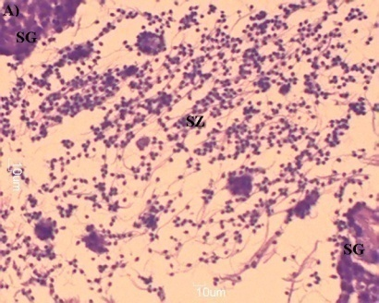
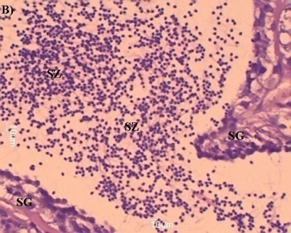
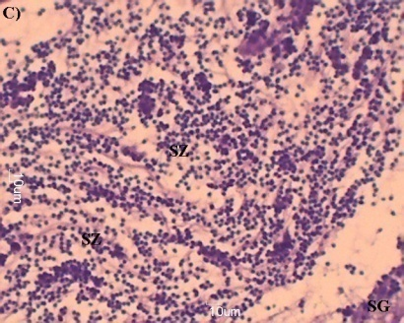

Figure 2: Effect of ZnAA treatment on testis histology of the C. macrocephalus. Cross section of testis treated with ZnAA and control: A) Control, B) ZnAA1 and C) ZnAA2. Spermatogonia (SG), and spermatozoa (SZ) scale bar: 1

Conclusion

The recent study indicated that the optimum zinc amino acid treatment in enhancing the Clariasmacrocephalusmale maturation and sperm quality is ZnAA2 (200 ppm ZnAA).

References

Areerat, S. 1987. Clariasculture in Thailand. Aquaculture 63: 205–214
Baker, D. H. and Ammerman, C. B. 1995. Zinc Bioavailability in Bioavailability of Nutrients for animals: amino acids. Minerals.and vitamins. Academic Press. Inc. 367 – 398
Clearwater, S. J., Farag, A. M., Meyer, J. S. 2002. Bioavailability and toxicity of dietborne copper and zinc to fisH.

